# Dataset for project:

The dataset for the project will be of top 10,000 artists of Spotify

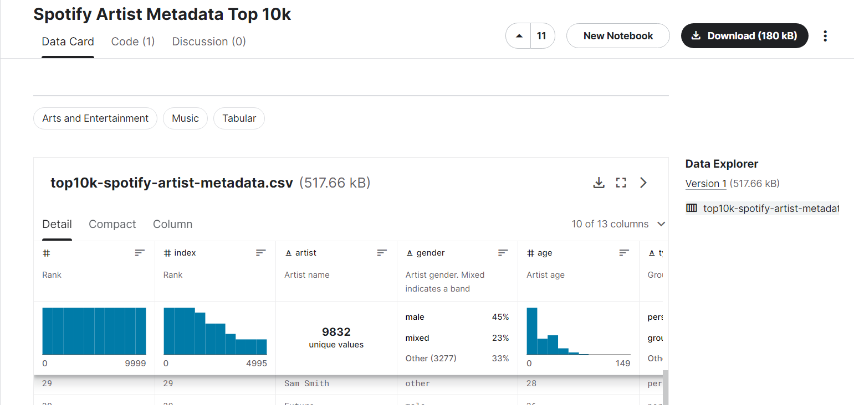

<https://www.kaggle.com/datasets/jackharding/spotify-artist-metadata-top-10k>

Here is the snippet from dataset :

